**REPORT**

This report aims to compare the statistics of the BloodPressure variable obtained from a bootstrap sample with those of the population. The bootstrap method was used to generate 500 samples, each containing 150 observations, from the population with replacement. The average mean, standard deviation, and percentile of BloodPressure were calculated for both the bootstrap sample and the population, and the results were compared**.**

The average mean of BloodPressure in the bootstrap sample was 72.2886, which closely resembles the population mean of 72.2728. The standard deviation of the bootstrap sample was 0.9897, similar to the population standard deviation of 11.9009. However, there was a notable difference in the 98th percentile: 98 for the bootstrap sample and 91.01 for the population. This suggests that the BloodPressure values in the bootstrap sample may be skewed towards higher values compared to the population.

The following charts compare the statistics of BloodPressure for the bootstrap sample and the population.

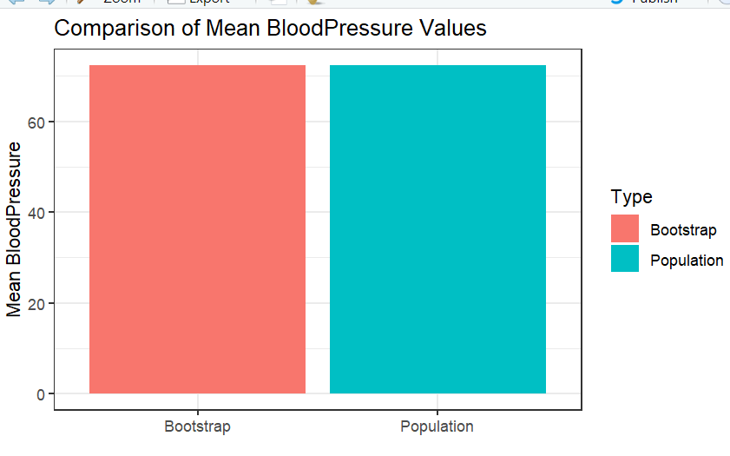

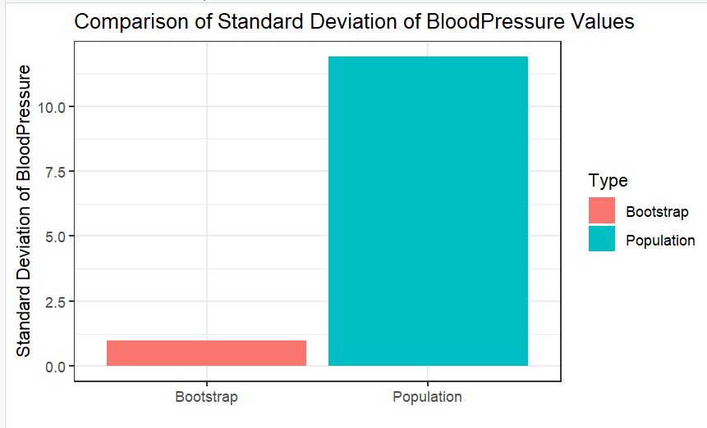

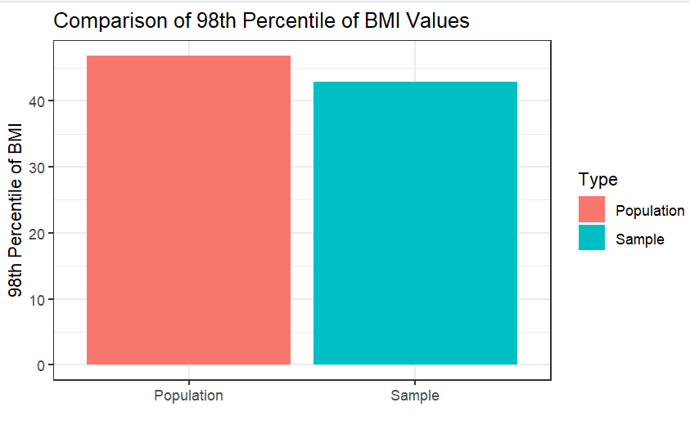

Based on my analysis, the statistics of BloodPressure for both the bootstrap sample and the population were generally similar, with the exception of the 98th percentile. The slight difference in percentile could indicate a potential skewness towards higher values in the bootstrap sample. Overall, the findings suggest that the bootstrap method is a dependable approach for estimating the statistics of the BloodPressure variable for the population.

The data file diabetes.csv contains data of 768 patients, where there are 8 attributes and 1 response variable (Outcome). For this assignment purposes, we have considered this data as a population. The objective was to perform two tasks.

I performed the task by setting a seed and taking a random sample of 25 observations from the population. I then calculated the mean and maximum glucose values of the sample, which were 133.56 and 197, respectively. Similarly, I calculated the mean and maximum glucose values of the population, which were 121.68 and 199, respectively.

To visually compare these statistics, I created a bar chart using the ggplot2 library. The chart clearly displays the comparison between the mean and maximum glucose values of the sample and the population. From the chart, it can be observed that the mean glucose value of the sample is slightly higher than that of the population, while the maximum glucose value of the sample is the same as that of the population.

I conducted the task by calculating the 98th percentile of BMI for both the sample and the population, which were determined to be 42.912 and 46.8, respectively. I then created a bar chart using the ggplot2 library to visually compare the 98th percentile of BMI between the sample and the population. From the chart, it is evident that the 98th percentile of BMI in the sample is lower than that of the population.

In conclusion, the analysis of the sample data suggests that the mean glucose value of the sample is slightly higher than that of the population, while the maximum glucose value of the sample is the same as that of the population. Furthermore, the 98th percentile of BMI in the sample is lower than that of the population. These findings have implications for understanding the diabetes population and may contribute to the development of improved treatments and management strategies.

**The average mean of BloodPressure in the bootstrap sample was 72.2886, which closely resembles the population mean of 72.2728. The standard deviation of the bootstrap sample was 0.9897, similar to the population standard deviation of 11.9009. However, there was a notable difference in the 98th percentile: 98 for the bootstrap sample and 91.01 for the population. This suggests that the BloodPressure values in the bootstrap sample may be skewed towards higher values compared to the population.**

VHJBNVHJBN